User Manual

eTimely

Version 1.0

April 19, 2022

Matt Korte

Caleb Obi

Chris Gumieny

Samia Chowdhury

# Revision History

|  |  |  |  |
| --- | --- | --- | --- |
| **Date** | **Description** | **Author** | **Comments** |
| 4/19/2022 | Version 1 | Matthew Korte  Caleb Obi  Chris Gumieny  Samia Chowdhury | Part of final project submission. |

# Table of Contents

Revision History ii

Table of Contents iii

1. Purpose 1

2. Sign Up - Business 1

3. Verify Email – Business 3

4. Sign In - Business 4

5. Business Dashboard 5

6. Team Management 6

7. Invite Staff 7

8. View Staff Availability 10

9. Role Management 11

10. Schedule Management 12

11. Sign Up - Staff 16

12. Sign In - Staff 18

13. Staff Dashboard 19

14. Staff Availability 20

15. Profiles 23

16. Announcements 24

17. Messages 26

# 1. Purpose

This document is meant to describe to a user how to use the eTimely application, whether they are a business or staff user. The basic flow for each use case will be described within this document, with some common mistakes and issues being described as well.

# 2. Sign Up - Business

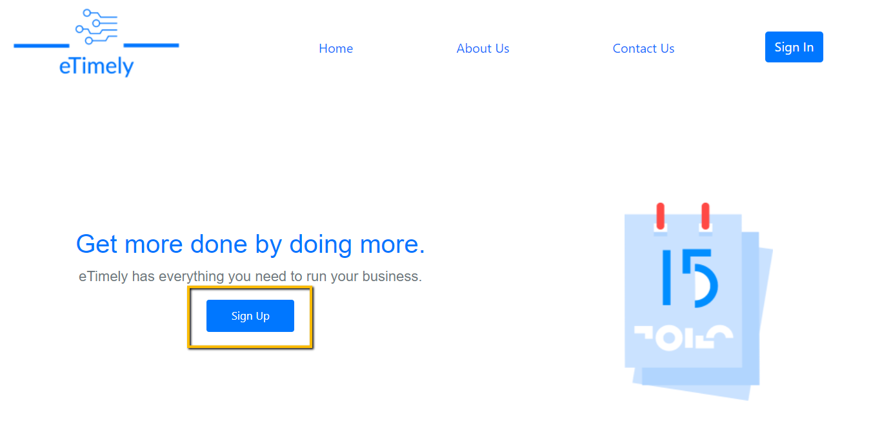

**Figure 2.1**

To create a new business account, the user can click on the “Sign Up” button found on the landing page.

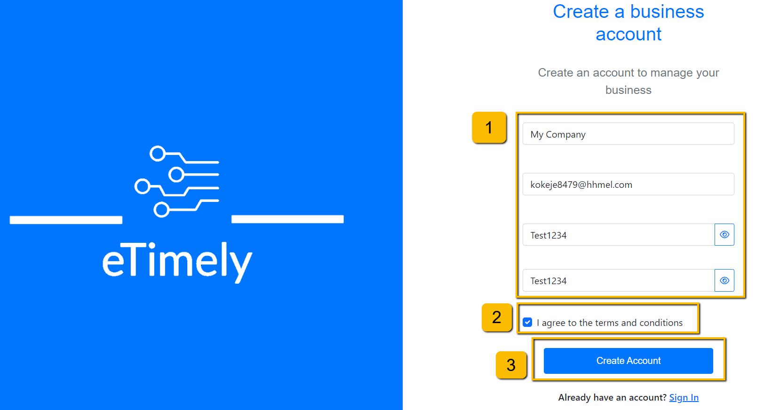

**Figure 2.2**

Once the “Sign Up” button is clicked, the user will be greeted with the business sign up form. Here, the user can create a business account by doing the following:

1. Fill out the following fields with the name of the business, the email to be associated with the account, and the password. To successfully make an account, the user must type in their password twice to confirm it.
2. Agree to the terms and conditions by clicking on the check box.
3. Click the “Create Account” button.

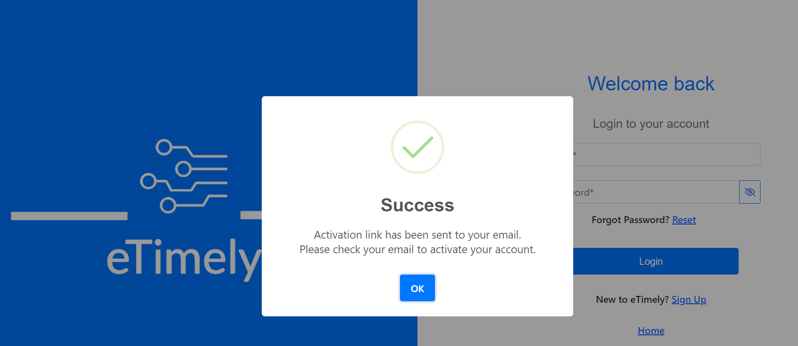

**Figure 2.3**

Once the user submits the form with information to create a business account, an activation link will be sent to the email submitted on the account creation page. The user will not be able to login until they verify the account in the email.

# 3. Verify Email – Business

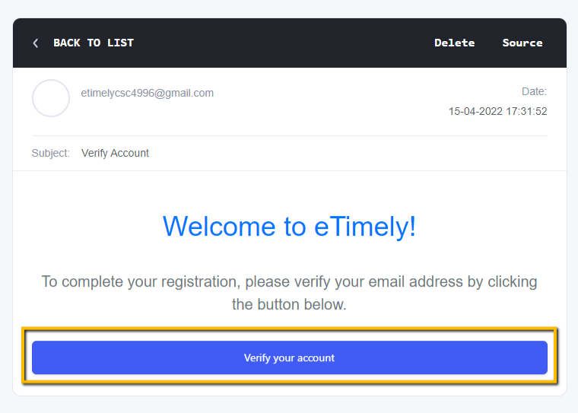

**Figure 3.1**

To verify a business account, the user must click the “Verify your account” button in the email that was sent after account creation. After the user clicks this button, the business account will be verified, and the user will be able to log in.

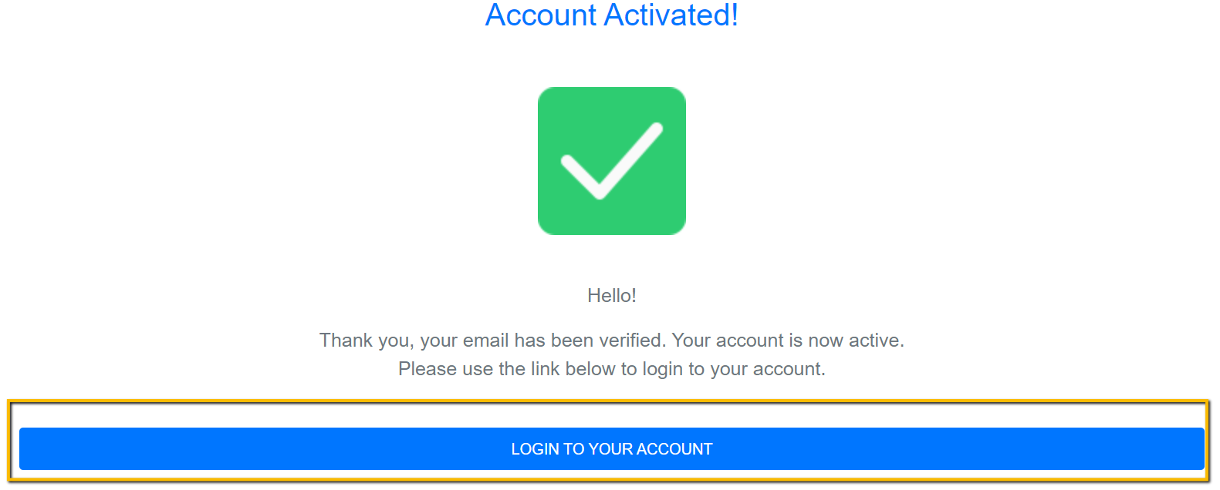

**Figure 3.2**

Once the user verifies the business account, they will be shown the “Account Activated” page. On this page the user will be able to click the “Login to your account” button to be redirected to the login page to login.

# 4. Sign In - Business

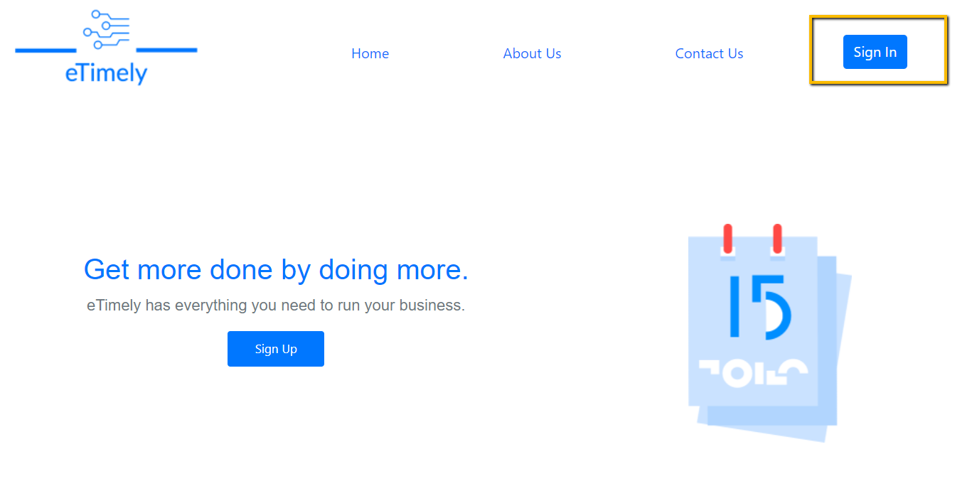

**Figure 4.1**

To sign into an account, the user must click the “Sign In” button at the top right of the page.

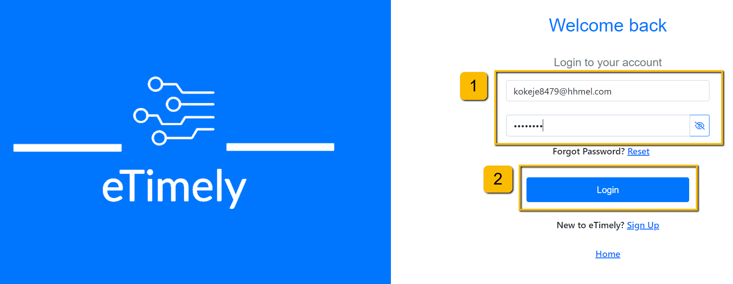

**Figure 4.2**

On the user login page, the user can sign in by doing the following:

1. Enter the email address of the account that the user is trying to sign into.
2. Enter the password for the specified account.

# 5. Business Dashboard

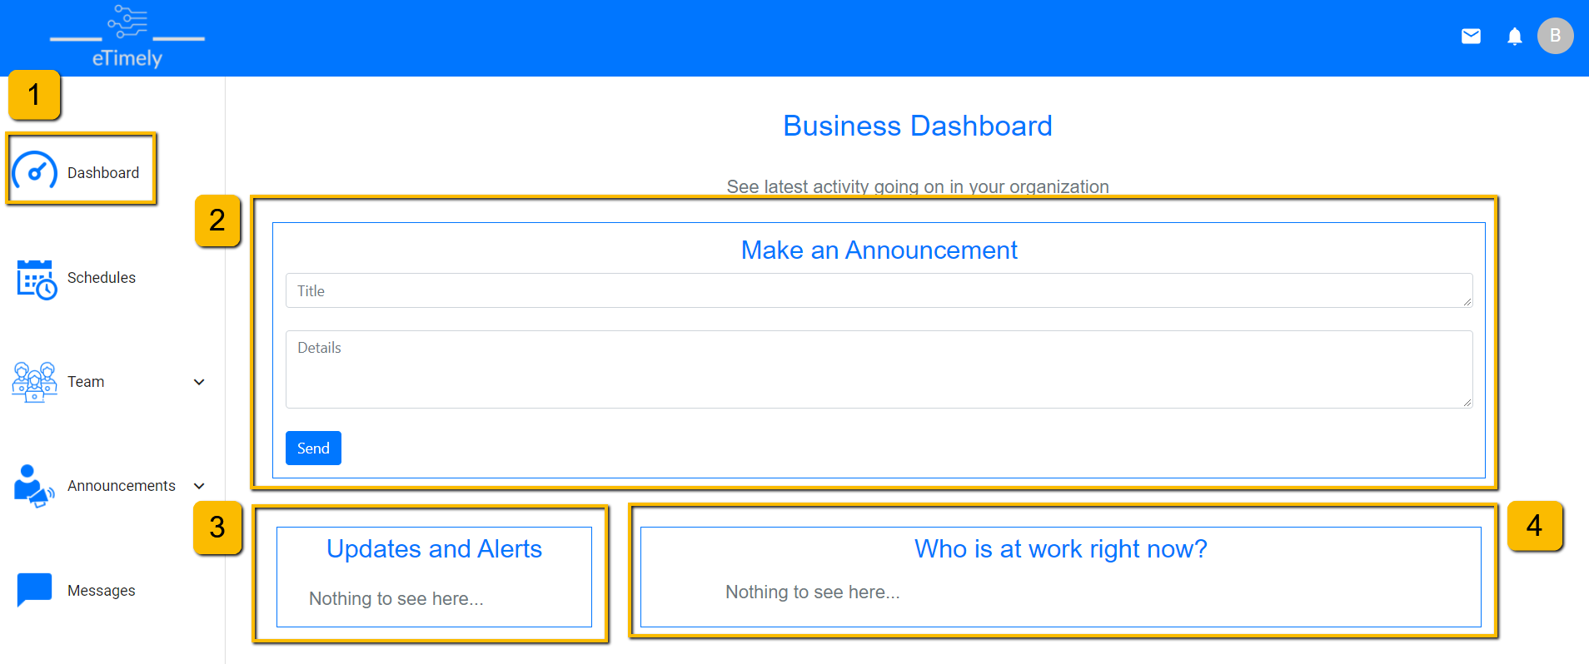

**Figure 5.1**

After a business user successfully logs in, they will be redirected to the business dashboard. There are a few different pieces of information that can be seen on this page.

1. The user can visit the business dashboard at any time by clicking the “Dashboard” tab in the sidebar.
2. Announcements can be made quickly from this page. The user can add a title and details for the announcement and then submit the announcement by clicking the “Send” button. An announcement will be sent to anyone in the organization.
3. In this section, the business user will be able to view newly added availabilities from any employees. Once an employee’s new availabilities are viewed, that employee will disappear from this box.
4. The “Who is at work right now?” section allows the business user to see any employees that are scheduled to work at the time that the business user has this page opened.

# 6. Team Management

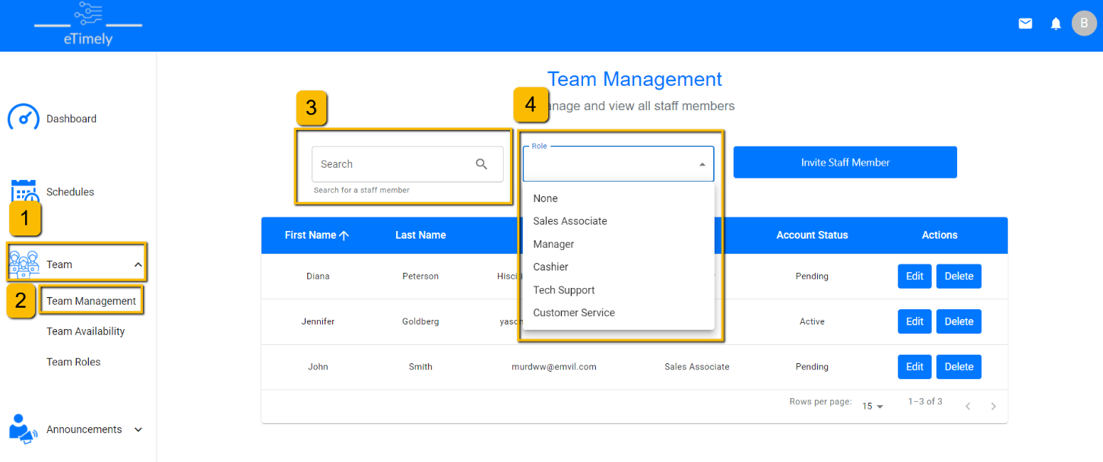

**Figure 6.1**

A business user can see a full list of staff users as well as search, filter and sort the list by doing the following:

1. Clicking the “Team” dropdown in the sidebar.
2. Visit the “Team Management” page by clicking the “Team Management” button in the sidebar.
3. Here, the user can search for a staff user by first name, last name or email address.
4. The user can select a role to filter the staff users based on who is assigned to that role.
5. The user can also sort each column of the team management table by clicking on the header of each column.

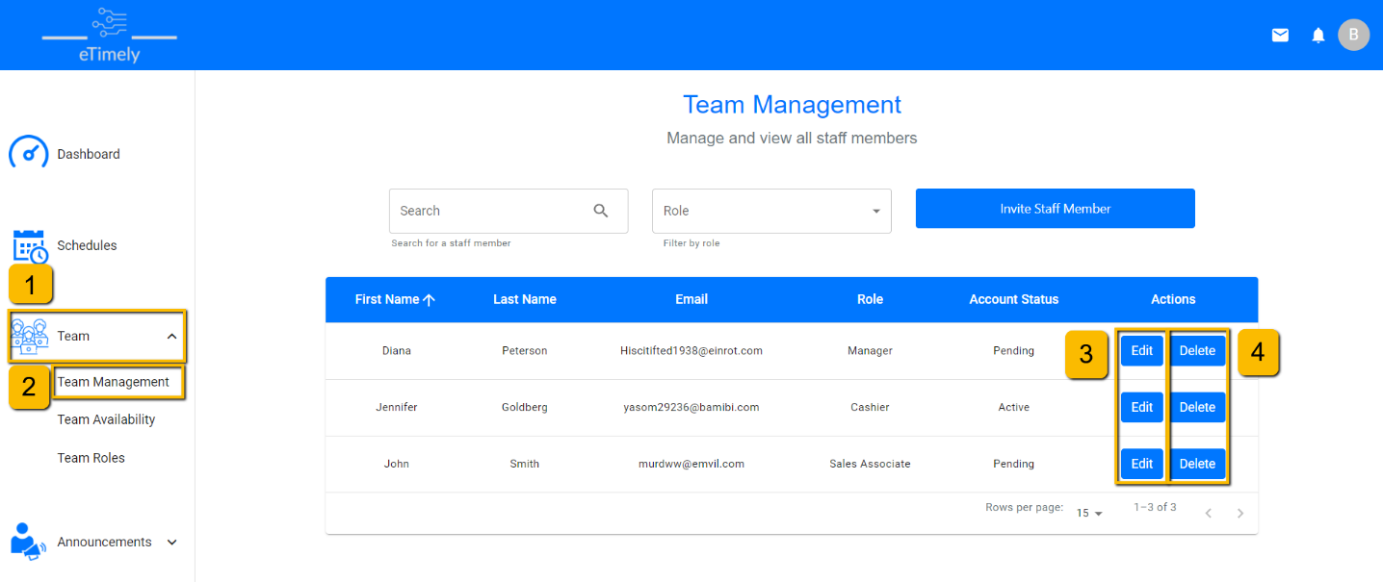

**Figure 6.2**

A business user can edit the information of staff users as well as delete any staff members and remove them from the organization.

1. Click the “Team” dropdown in the sidebar.
2. Visit the “Team Management” page by clicking the “Team Management” button in the sidebar.
3. By clicking the “Edit” button, the user can edit the role that is assigned to a staff user.
4. If the user wants to delete a staff user’s account and effectively remove them from the organization, the user can click the “Delete” button. When a staff user is deleted, all schedules and availabilities tied to that user will be deleted.

# 7. Invite Staff

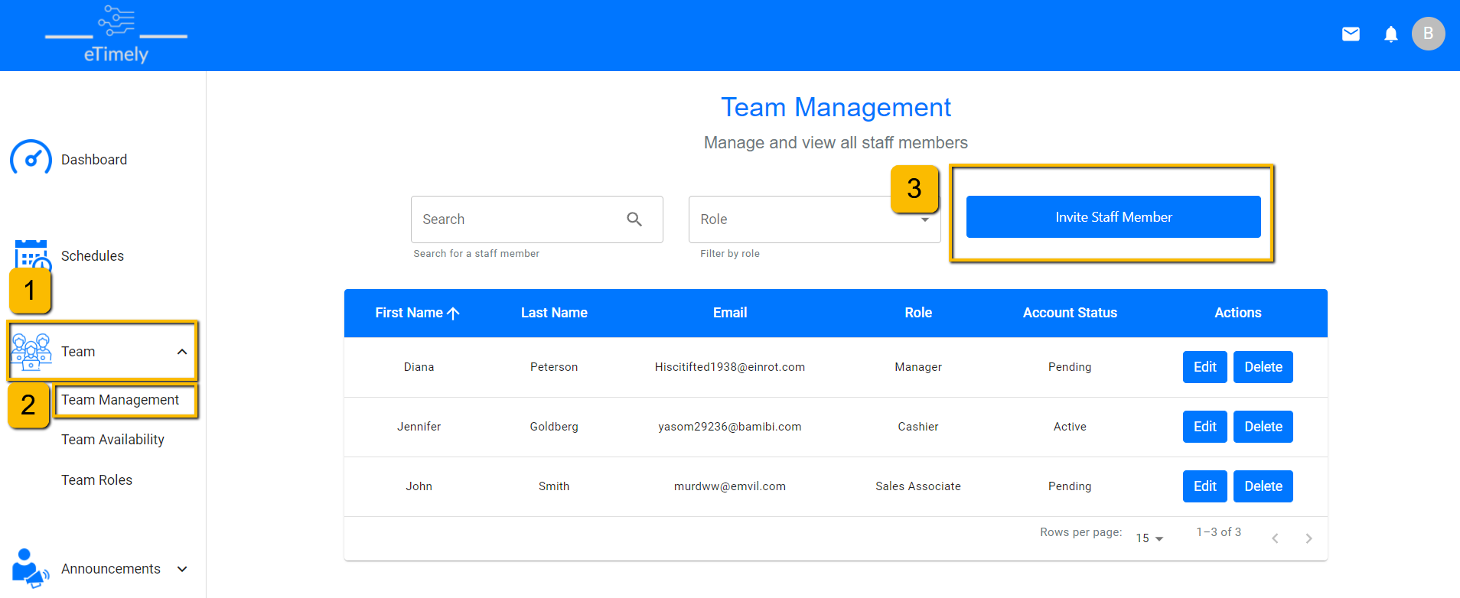

**Figure 7.1**

A staff member can be invited to the organization by following these steps:

1. Click the “Team” dropdown in the sidebar.
2. Visit the “Team Management” page by clicking the “Team Management” button in the sidebar.
3. Click the “Invite Staff Member” button.

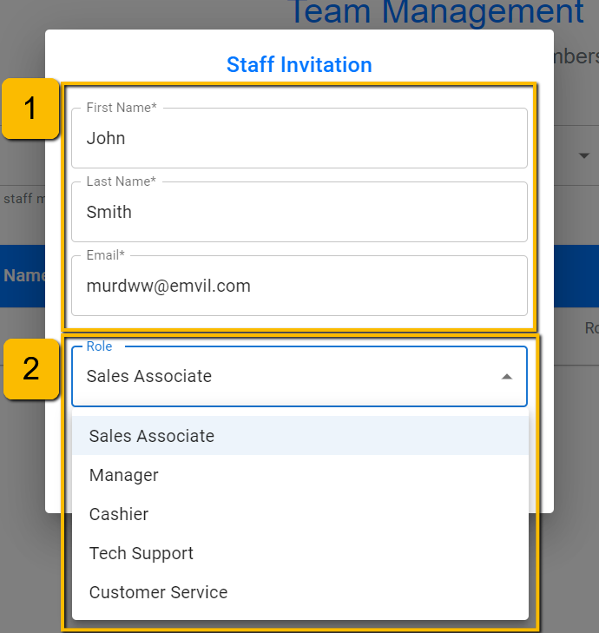

**Figure 7.2**

In the “Staff Invitation” form. The business user must fill out the following information to successfully send an invitation.

1. Enter the first name, last name, and email address of the staff member that needs to be invited.
2. Select a role from the dropdown to assign that role to the newly invited staff member.

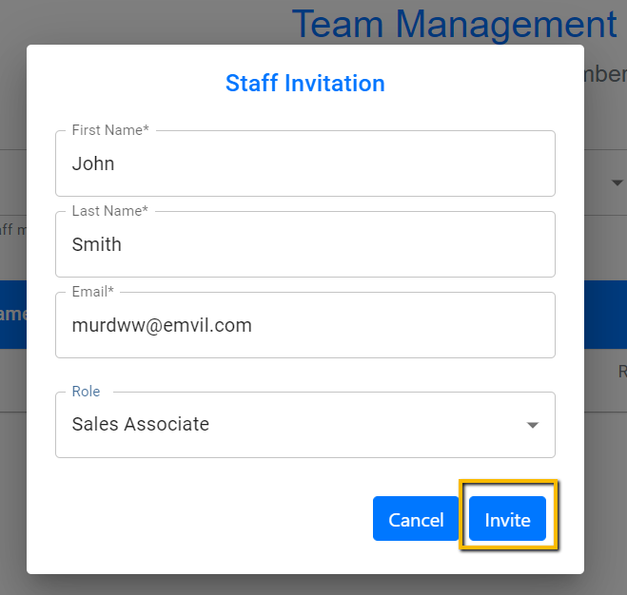

**Figure 7.3**

Once the staff user information is filled out, the business user can send the invitation by clicking the “Invite” button. An invited staff user will have an account status of “Pending” until they complete the sign up by setting a password for the account.

# 8. View Staff Availability

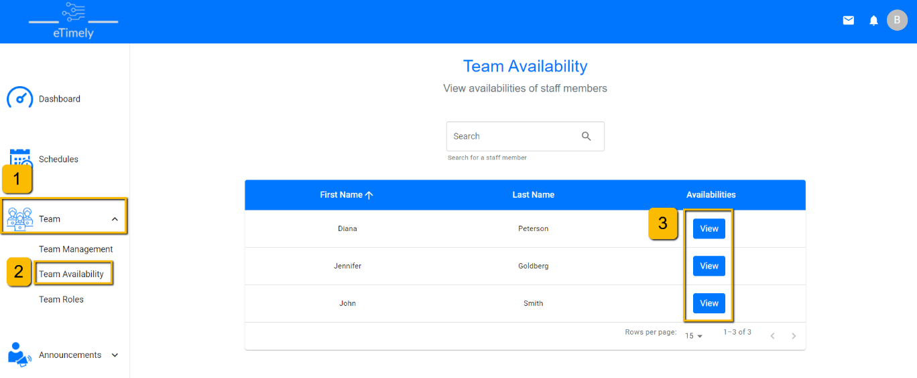

**Figure 8.1**

A business user can view the availabilities of all staff users on the “Team Availability” page by doing the following:

1. Click the “Team” dropdown in the sidebar.
2. Visit the “Team Management” page by clicking the “Team Management” button in the sidebar.
3. Click the “View” button for the specific staff user to view their availability.

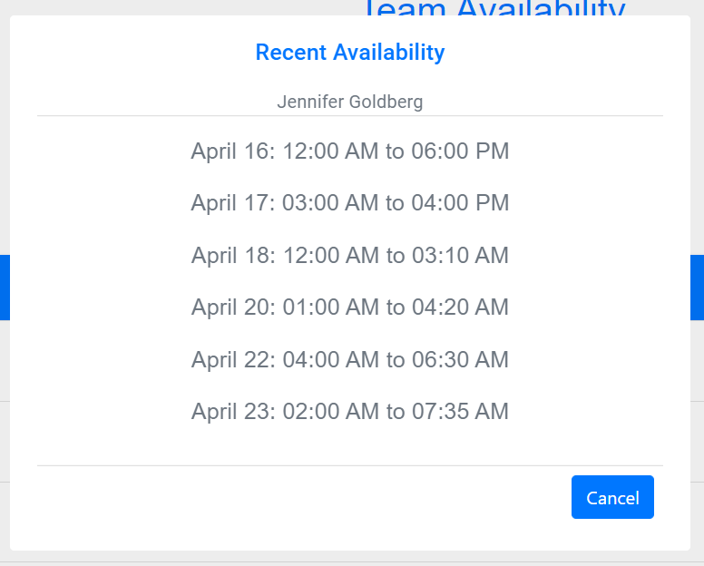

**Figure 8.2**

Once the user clicks the “View” button for an employee, a pop-up window will open. This pop-up window will show up to 7 of the latest timeslots that the employee added to their availability.

# 9. Role Management

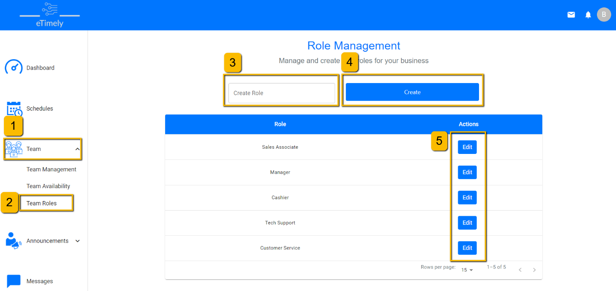

**Figure 9.1**

A business user can create, edit, and delete roles by doing the following.

1. Click the “Team” dropdown in the sidebar.
2. Visit the “Team Roles” page by clicking the “Team Roles” button in the sidebar.
3. In the “Create Role” input box, the user can input the name of a role that they want to add to the organization.
4. Once the user has typed in a role name, they can create the new role by clicking the “Create” button.
5. The user is also able to edit and delete roles. Clicking the “Edit” button next a role will allow the user to change the name of that role. The name of the role will change everywhere that the role is used throughout the application. If there are more than 5 roles in the organization, then the user will be able to delete any roles until the total number of roles goes down to 5. This can be done by clicking the “Delete” button next to the role that the user wants to delete.

# 10. Schedule Management

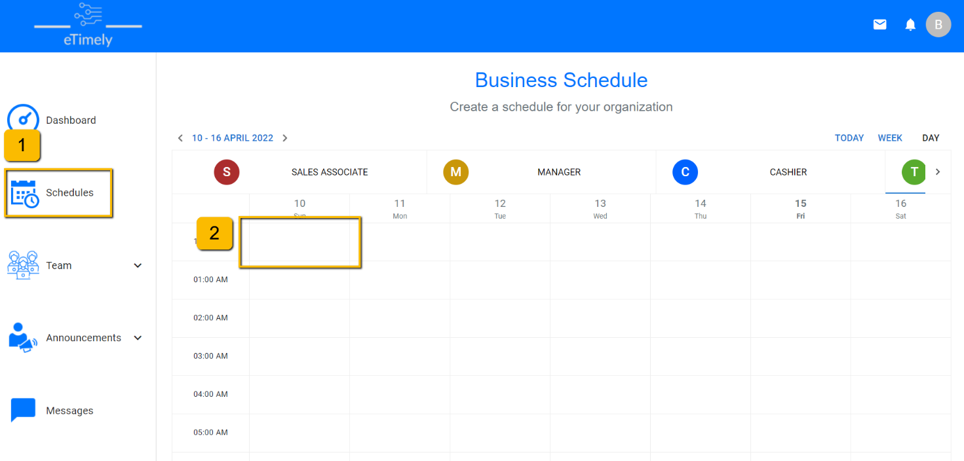

**Figure 10.1**

To schedule a staff member, a business user can:

1. Navigate to the “Schedules” page.
2. Click anywhere on the calendar to open a dialog box to input schedule information.

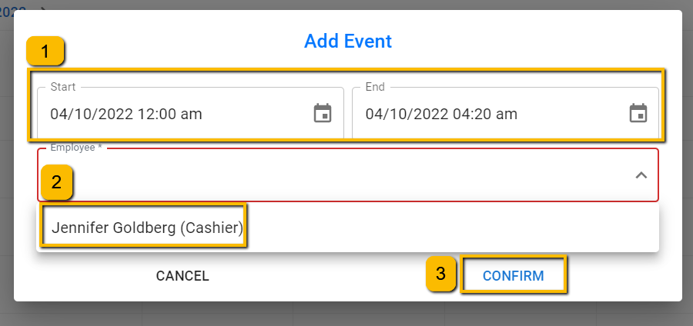

**Figure 10.2**

Once the dialog box is open, business user can:

1. Enter start and end times.
2. Select the employee they want to schedule from the drop-down menu.
3. Press “Confirm” to schedule that staff member.

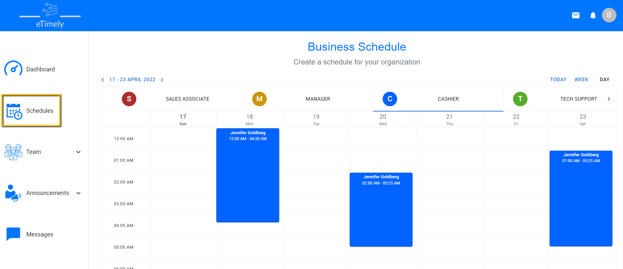

**Figure 10.3**

Once staff member is scheduled, the shift can be viewed by the business user by clicking on the appropriate role tab.

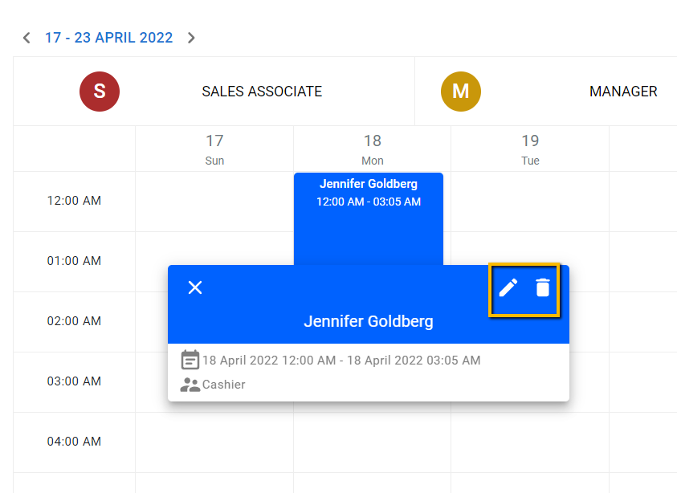

**Figure 10.4**

Additionally, if the user clicks on the shift, they can click the corresponding button to edit or delete the shift.

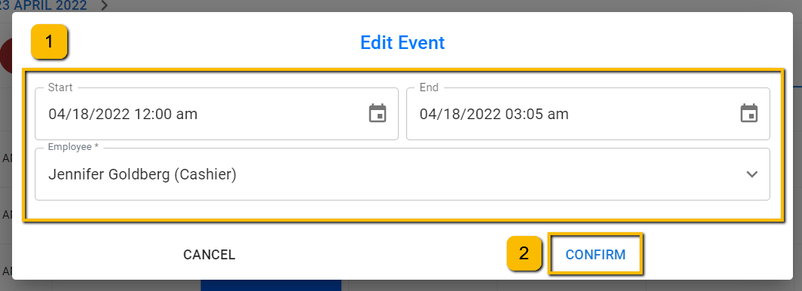

**Figure 10.5**

Once clicking the edit button, the same dialog box as creating a new shift is opened. This time it is prefilled with the current information for that shift. Here the user can:

1. Edit the start and end times, as well as the scheduled employee
2. Press the “Confirm” button to save any changes made.

In the event the staff user being scheduled is not available for the time they are being scheduled; a message will be shown on screen to alert them of this. It will ask if business user is sure they want to schedule this staff member.

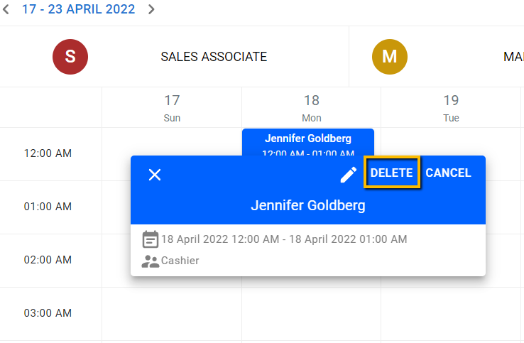

**Figure 10.6**

After press the delete icon, above “Delete” and “Cancel” options are shown to allow the user to confirm they want to delete the shift. If the “Delete” button is pressed, the shift is removed.

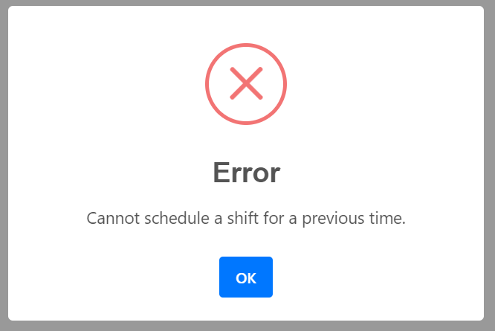

**Figure 10.7**

If a user makes an error while entering or editing a shift, they will be shown an error message similar to the one shown above. These errors include:

* Attempting to enter or edit shift for a date that has already passed
* Having a start date that occurs after the end date. An example of this would be having a start date of 4/10/2022 at 12:00pm and an end date at 4/10/2022 at 11:00am.
* Entering information that overlaps with information that was previously entered.

# 11. Sign Up - Staff

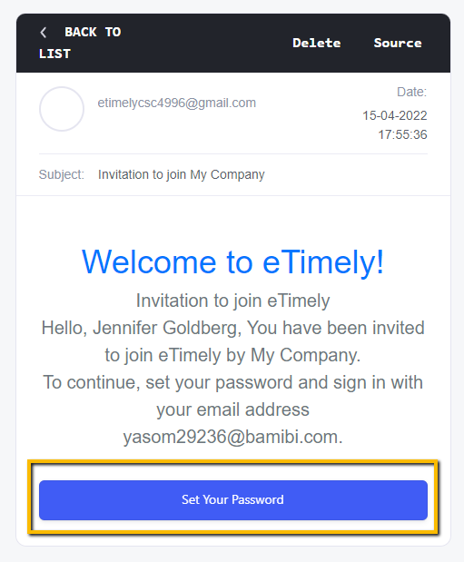

**Figure 11.1**

After the business user has sent an email invite for a staff user, they can press the “Set Your Password” button in the email sent to the address entered by the business user. The user has 24 hours to use this link before it expires.

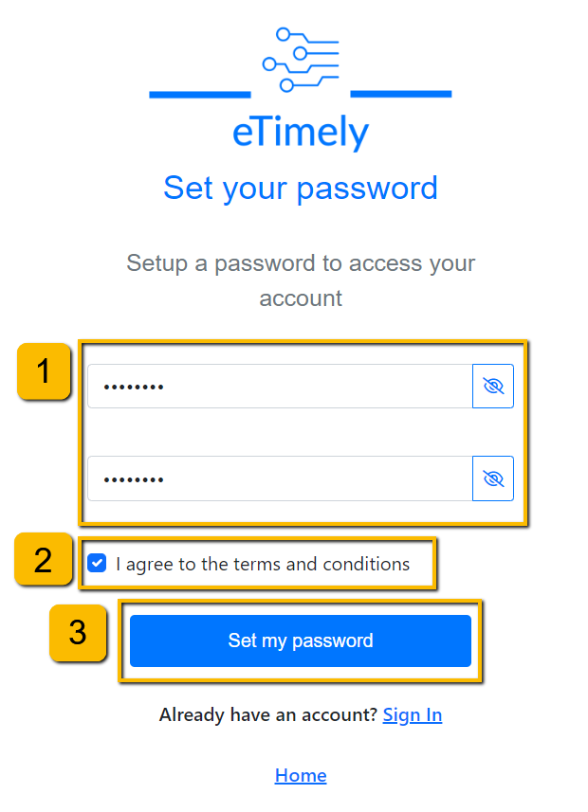

**Figure 11.2**

Upon opening the link, the user will be able to:

1. Set their password by entering it into the fields.
2. Agree to the terms and conditions.
3. Press “Set my password” to set the password to what is entered in the fields in step 1.

# 12. Sign In - Staff

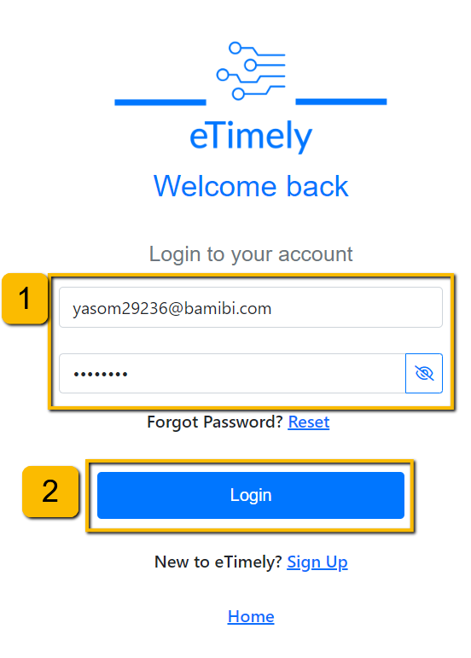

**Figure 12.1**

Once the staff user sets their password, they will be redirected to the sign-up screen (this is the same page that can be reached from the home page). To sign in the user must enter:

1. Their account email and password.
2. Press “Login” to be redirected to their dashboard.

# 13. Staff Dashboard

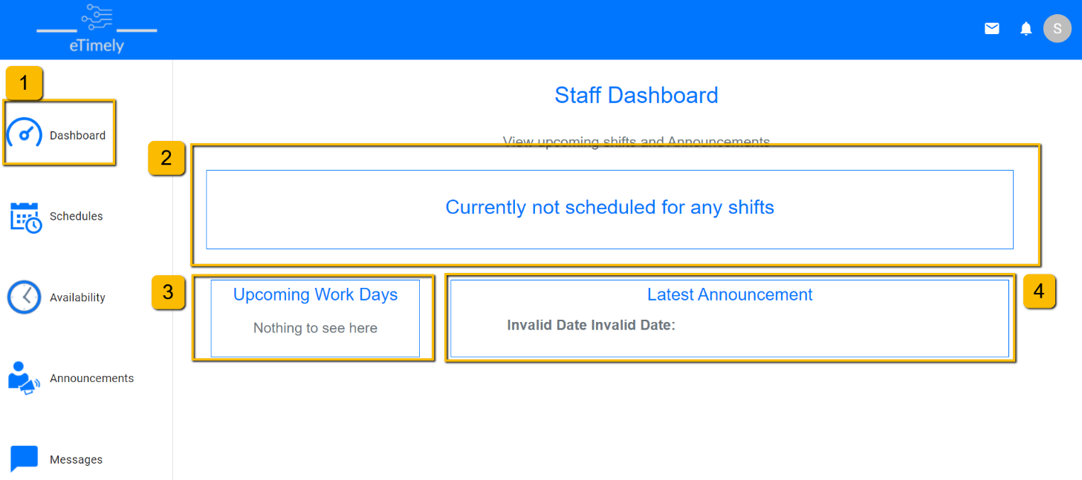

**Figure 13.1**

After a staff user successfully logs in, they will be redirected to the staff dashboard. There are a few different pieces of information that can be seen on this page.

1. The user can visit the staff dashboard at any time by clicking the “Dashboard” tab in the sidebar.
2. The user will be able to view the next shift that they are currently scheduled for.
3. In this section, the user will be able to see any upcoming shifts that they are scheduled for.
4. The user will also be able to view the latest announcement sent by the business user to the organization.

# 14. Staff Availability

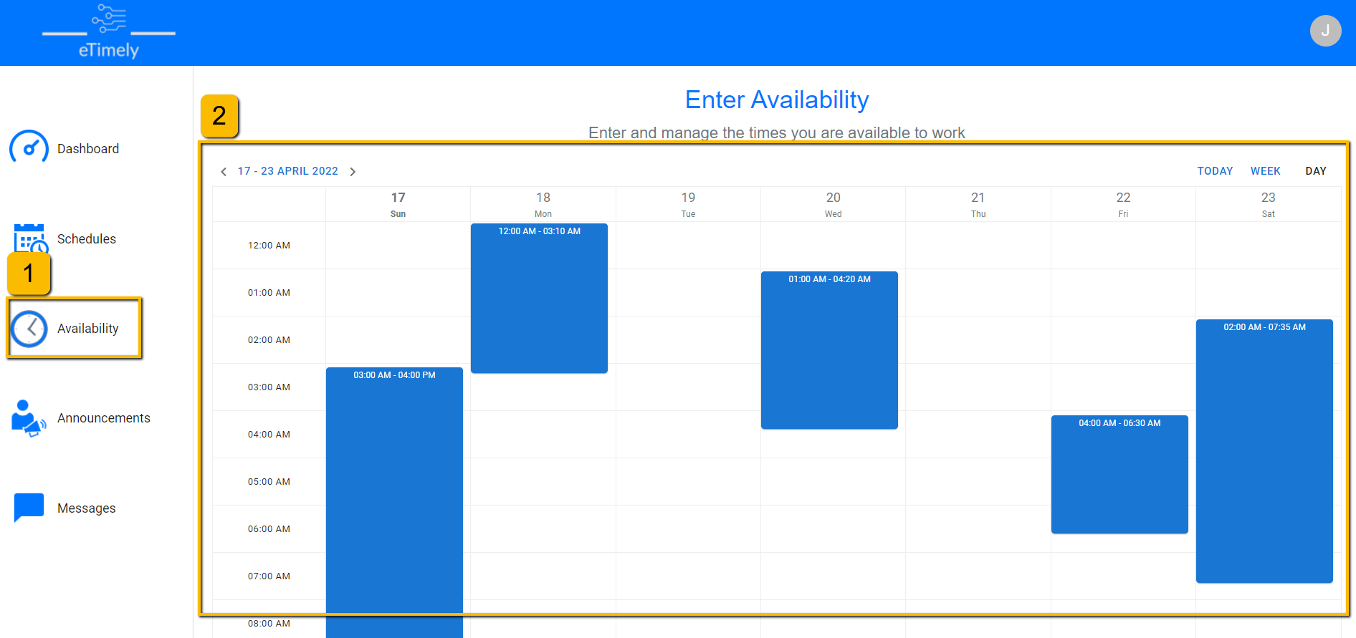

**Figure 14.1**

Staff members can also enter information on when they are available to work by:

1. Clicking the “Availability” navigation button.
2. Clicking anywhere inside of the schedule to open a dialog box.

**Figure 14.2**

Once the dialog box is opened a user can:

1. Enter both the start and end times for their availability window.
2. Press “Confirm” to submit the input information.

**Figure 14.3**

After some availability information is entered, the “Availability: screen will look like the above screenshot. Any availability information can also be edited by clicking on the corresponding blue box.

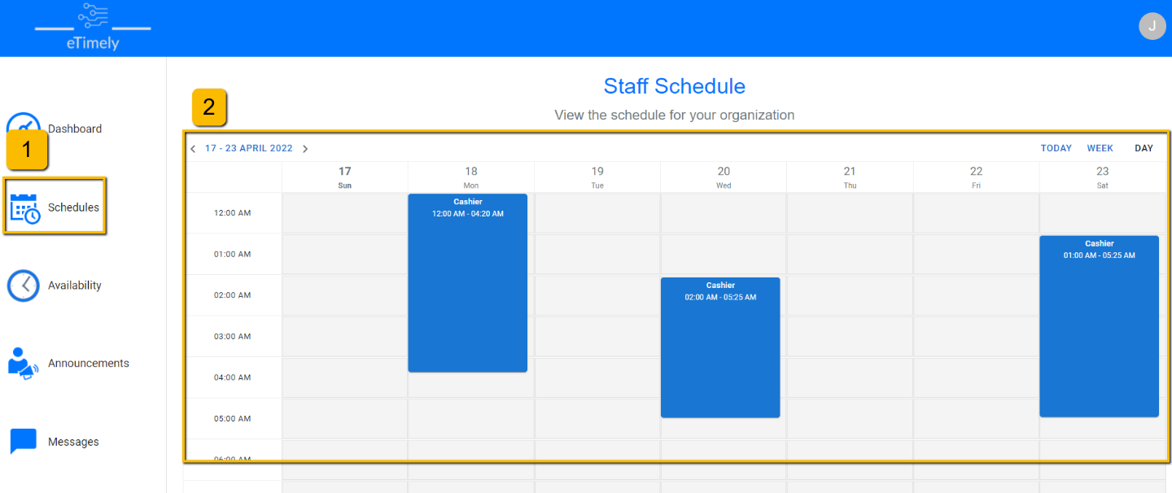

**Figure 14.4**

The staff user can view their schedule by doing the following:

1. Clicking the “Schedules” link in the sidebar.
2. Any shifts that the staff user is scheduled for will show up in the schedule on this page.

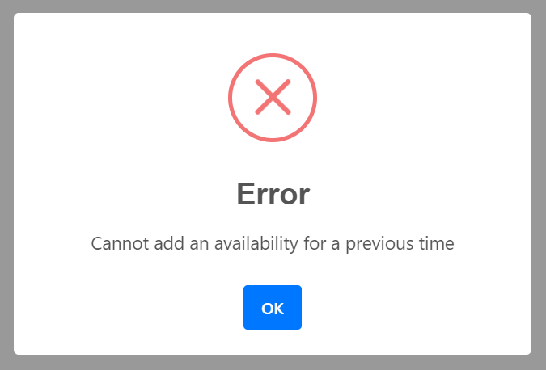

**Figure 14.5**

If a user makes an error while entering an availability, they will be shown an error message like the one shown above. These errors are:

* Attempting to enter or edit availability for a date that has already passed
* Having a start date that occurs after the end date. An example of this would be having a start date of 4/10/2022 at 12:00pm and an end date at 4/10/2022 at 11:00am.
* Entering information that overlaps with information that was previously entered.
* Entering information that is a duplicate of another previously entered availability.

# 15. Profiles

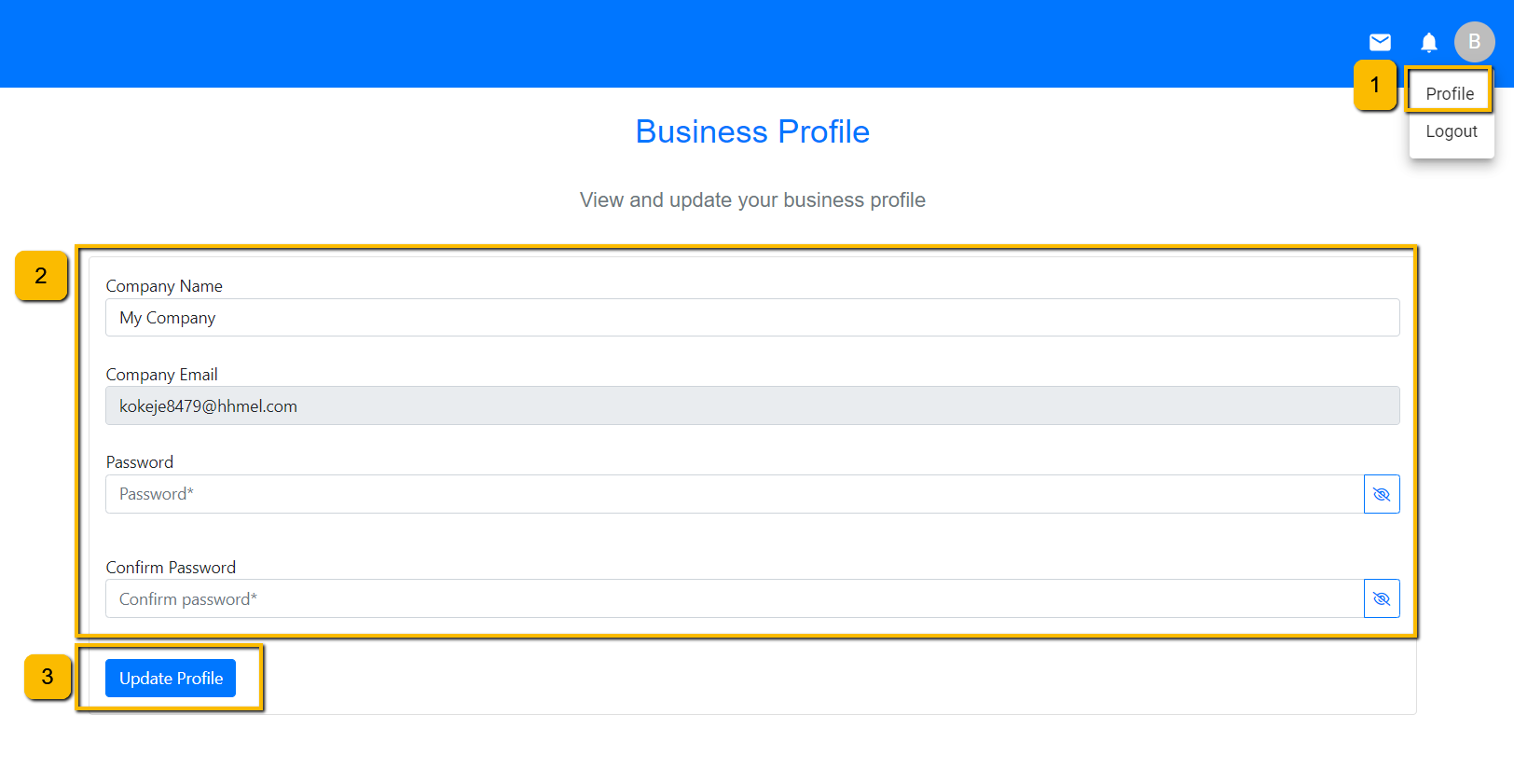**Figure 15.1**

Business users can edit their profile by:

1. Clicking on the user icon in the top right corner.
2. Editing the open fields. Note, company email cannot be changed.
3. Clicking update profile.

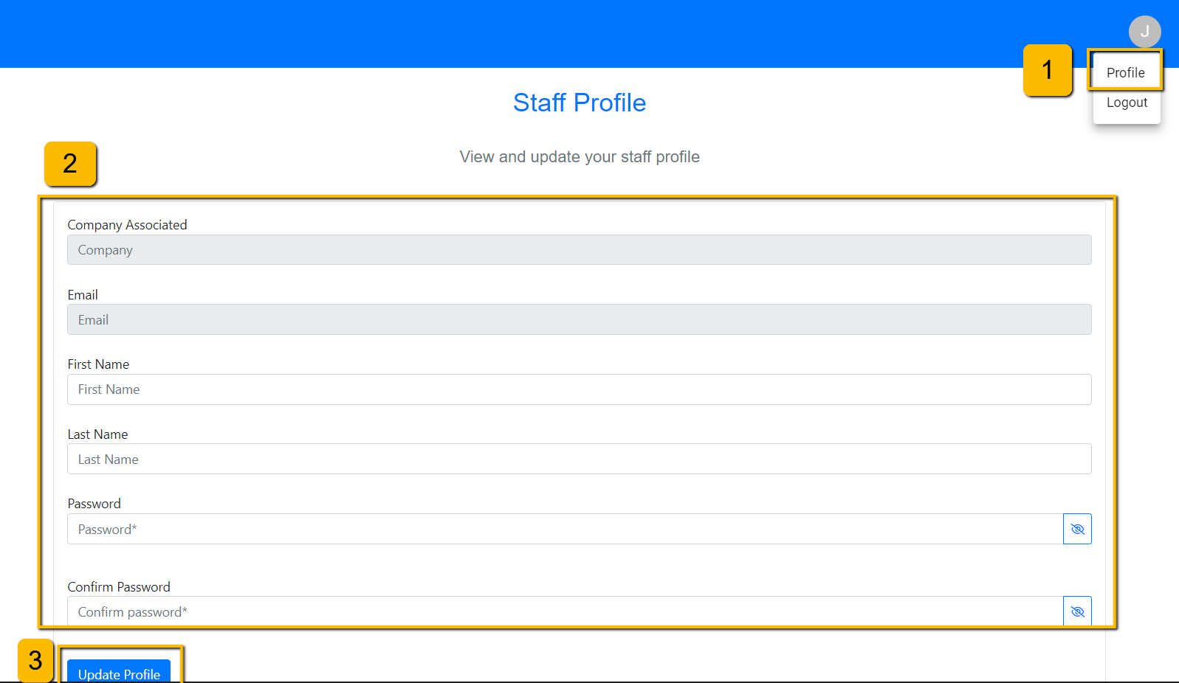**Figure 15.2**

Staff users can edit their profile by:

1. Clicking on the user icon in the top right corner.
2. Editing the open fields. Note, Company Associated and Email cannot be changed.
3. Clicking update profile.

# 16. Announcements

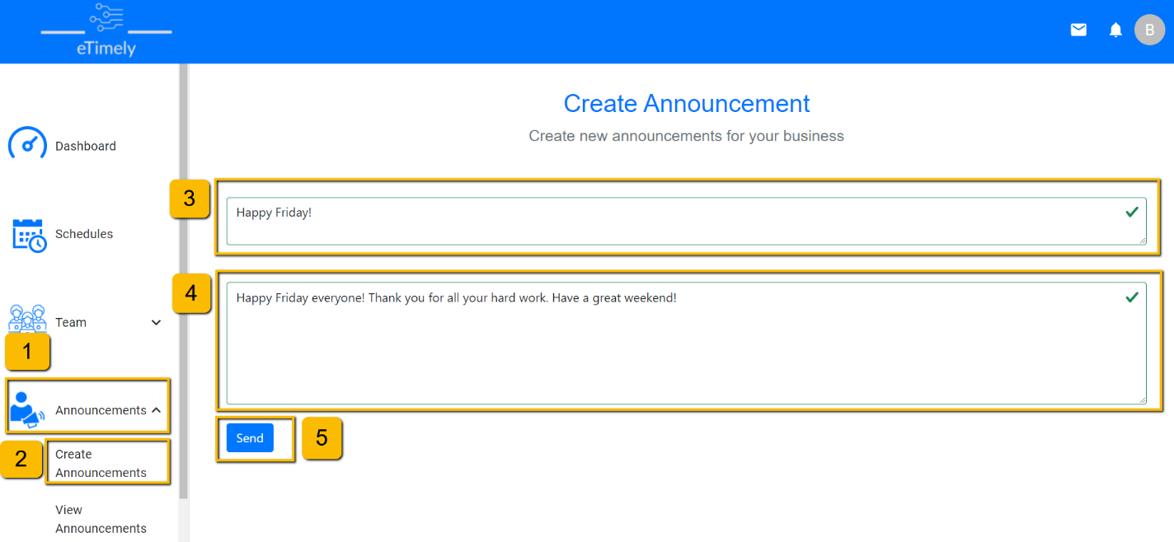

**Figure 16.1**

Business user will be able to make an announcement for all users in the organization to view by:

1. Opening the “Announcements” navigation drop down.
2. Clicking “Create Announcements”.
3. Entering a title between 5 and 50 characters long in the “title” box.
4. Entering the announcement details between 10 and 500 characters in the details box.
5. Clicking enter to submit the announcement.

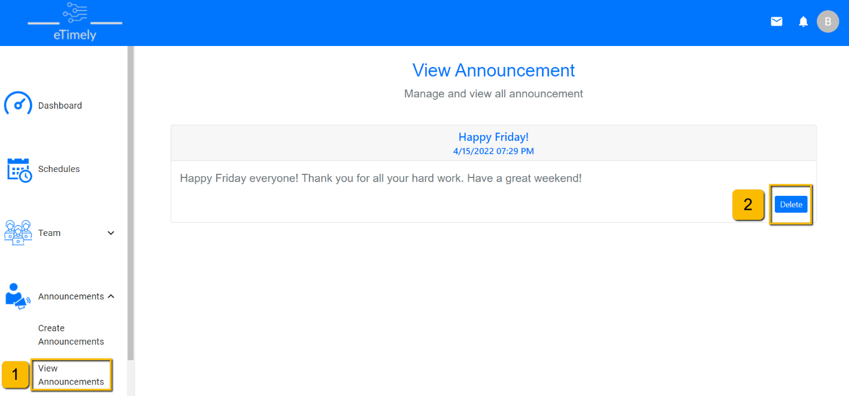

**Figure 16.2**

To view a previously made announcements a user can:

1. Navigate to the “View Announcement” page if using a business account, or just the “Announcements” page if they are a staff user.
2. If a business user is signed in, they can delete past announcements as well using the “Delete” button.

# 17. Messages

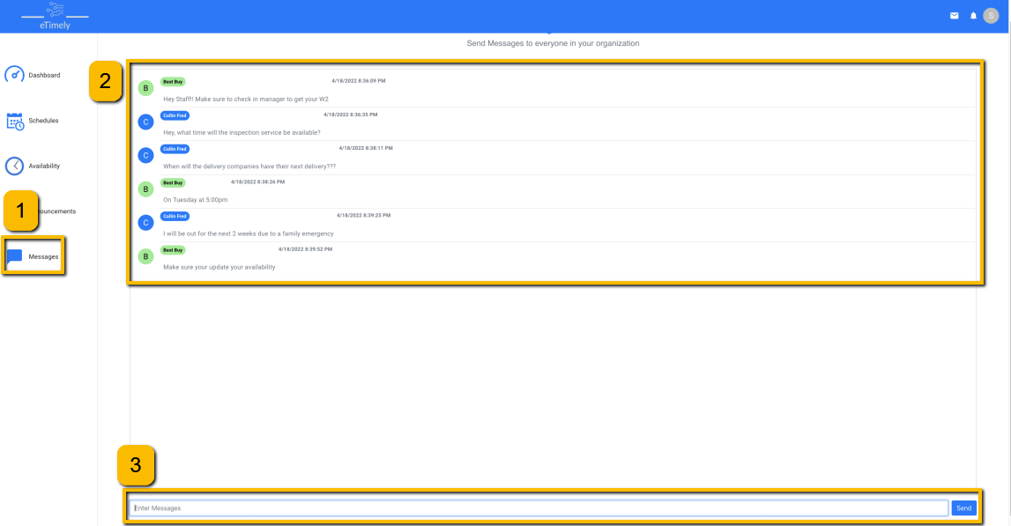**Figure 17.5**

Users can send and receive messages by doing the following:

1. Clicking on the Message tab on the left navigation.
2. Past messages will be available on the top part of the screen.
3. Any new message can be created using the text field on the bottom of the screen.